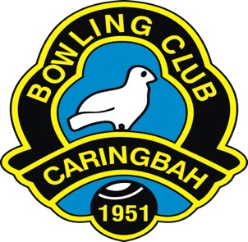

CARINGBAH BOWLING & RECREATION CLUB
“the friendly club”
BAREFOOT BOWLS PARTY BOOKING FORM

Party Date  _____/_____/_____ | Party time  _______ am /pm
Number of Bowlers
____________

Contact Name: __________________________ Phone Number: _________________________
Email: _________________________________
I have read and understand the “Barefoot Bowls Party Conditions” and agree to abide in full by the terms stated therein. I am aware that at NO TIME is food or drink permitted on the green and that persons under the 10 are NOT permitted on the greens. I also agree that failure to comply with these conditions could result in cancellation of the party.
Party Host Signature: ________________________________

Barefoot Co-ordinator Signature: _______________________________

Bowlers must pay at the Bar and receive a receipt and a coloured wrist band. Only people wearing a wrist band will be allowed to bowl or be on the green at any time.

